Dallin Christensen

TECH 201

12/9/2013

**Final exam take-home assignment**

Due to BYU building ordinances, a new campus building could only be built to replace a current building[1][2]. I would build the building where the Fletcher Building currently stands (in-between the Wilkinson Center and the Clyde Building). The Fletcher Building is an old building that has a large footprint, but not a lot of foot traffic. It is in an ideal spot on campus, close to the other technology buildings (the Clyde and Crabtree buildings), but also close to the library and not far from the JFSB and JKB. Putting the new Technology & Creativity Building there would make it easily accessible to students, no matter what their major. Engineering majors would only be a building away from it for the majority of their classes and humanities/English majors would be very close as well. Also, because it is by the Clyde and Crabtree buildings, both of which are more than two stories tall, the new building could be built five stories tall (four above ground with one basement floor) without looking out of place or imposing on the landscape.

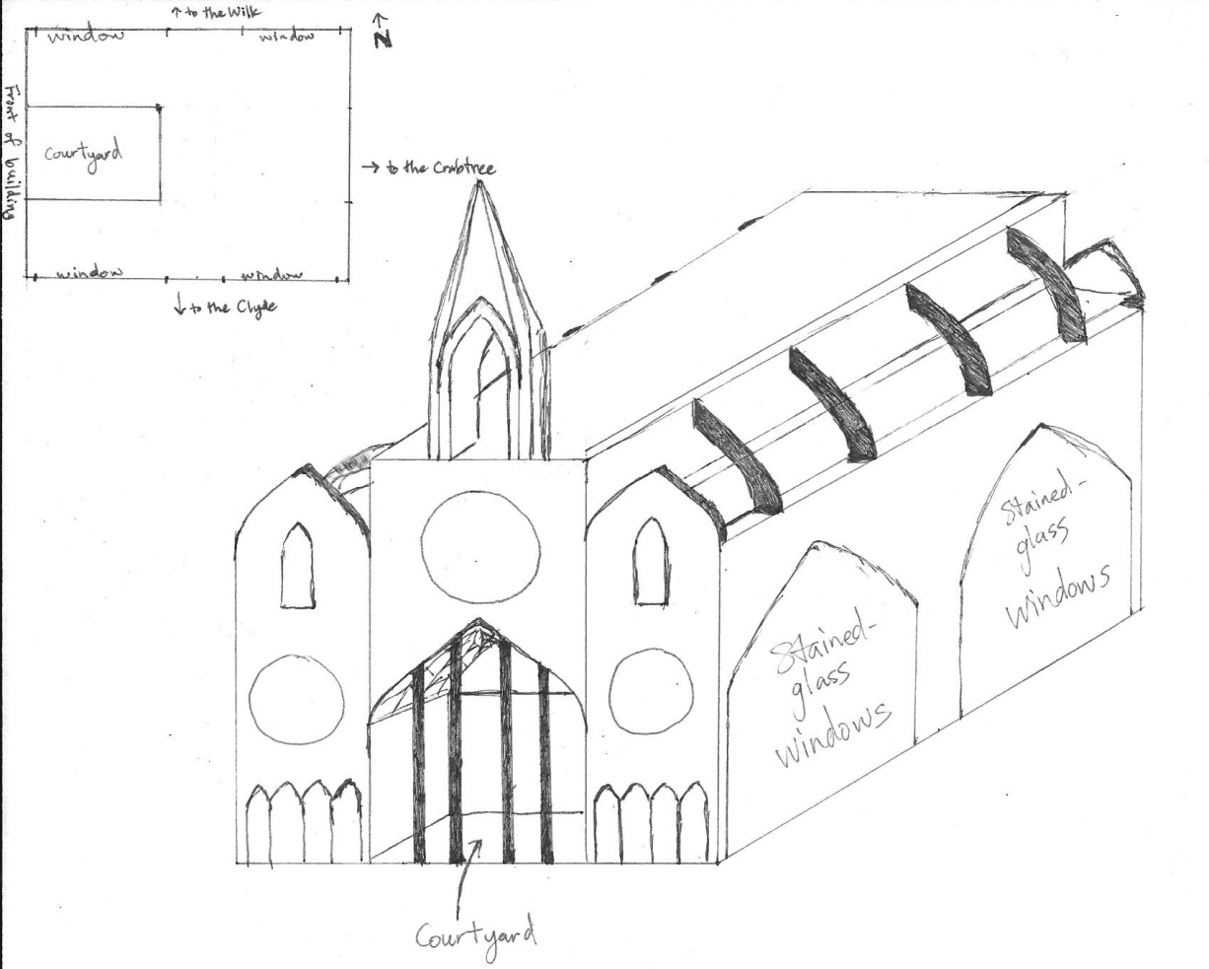

Gothic Elements

1 – Tall

The front, main spire of the building would also be very tall, making the building appear even taller than it actually is. The majesty of the building would awe students and visitors alike as they enter the building.

The nave (center of the building) would extend the length of the building at 2 1/2 stories tall and would be partially indoors, partially open-air. The courtyard at the front would be open air and account for 1/3 the length of the nave. It would add a modern feel while maintaining Gothic architecture.

I chose to build the building relatively tall (by BYU standards) so that it stands out, but not so tall that it is the only building that people notice on campus.

2 – Pointed arches

Pointed arches would be prominent everywhere: doorways, windows, hallways, and the ceiling of the nave. Because pointed arches are the most well-recognized Gothic feature, no room could be without pointed arch windows or doors. I chose to use pointed arches because the building wouldn’t be truly Gothic without them. Also, they would make the building stand apart from the other buildings on campus, giving it a unique feel and appeal.

3 – Rib vaults

Although you can’t really see it in my sketch, the ceiling of the nave would be a ribbed vault ceiling. This feature is commonly used in Gothic churches. Even though the building would be used for academic purposes, the high ceilings would make the new building’s nave ideal for events such as galas and presentations/lectures.

4 – Large windows

On the north and south sides of the building would be two large stained-glass windows that extend as tall as the nave (2 1/2 stories). These large windows would allow a lot of light into the building, a distinctive characteristic of Gothic architecture.

5 – Flying buttresses

The fourth story of the building would only be the central section of the building and would be supported by flying buttresses that connect with the outer walls. Besides looking super cool, the flying buttresses would provide adequate support for the walls of the inner section of the building. Creatively, the buttresses would not run to the ground, but rather to the top of the outer walls (which will only be three stories tall).

1. I can’t seem to find a legitimate source for this, but I know I heard it once before. And history seems to support it: the new Life Sciences building will replace the Widtsoe Building, the JFSB was razed before being completely rebuilt, and the Hinckley Building was built on land formerly occupied by the Alumni House.
2. This probably isn’t considered “creative” but I believe in adhering to reality, even when doing creative assignments.